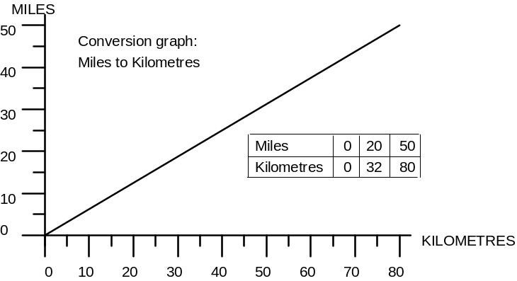Conversion Graphs

- Copy and complete the following table using the above conversion graph.

FROM | TO | MILES | KILOMETRES
York | Middlesborough | 49
Chichester | Brighton | 31
Norwich | King’s Lynn |  | 69
Leeds | Manchester |  | 64
Hereford | Worcester | 25
Liverpool | Chester |  | 29
Dundee | Perth | 20
Truro | Land’s End |  | 59

- Plot a conversion graph using the following table:

TONS | 0 | 1 | 8 | 2cm to 1 ton
KILOGRAMS | 0 | 1016 | 8128 | 2cm to 1000kg

- The heaviest Christmas pudding ever made weighed 3¼ tons. What was its weight in kg?
- The world’s largest ice-lolly was one of 5600kg. What was its weight in tons?
- The largest sherry trifle on record was one weighing 3130kg. How much did it weigh in tons?
- The heaviest doughnut ever made weighed 1²/₃ tons. How heavy was it in kg?

- Plot a conversion graph using this table.

PINTS | 0 | 3500 | 17 500 | 1cm to 1000 pints
LITRES | 0 | 2000 | 10 000 | 1cm to 1000l

- The largest milkshake was a chocolate one of 7200 litres. How many pints is this?
- The largest cocktail on record was a “Hurricane” consisting of 6000 litres. How many pint glasses would you need?
- The largest bottle in the world can hold 1100 pints. How many litres is this?
- The world’s largest jelly was a watermelon flavoured one of 60 000 pints. Without extending your graph can you find out how many litres this is?

- Use this table to construct a conversion graph.

° Celsius | 0 | 30 | 100 | Use a sensible scale of your choice.
° Fahrenheit | 32 | 86 | 212 | Use a sensible scale of your choice.

- Benzine freezes at 6°C. What is this in °F?
- Acetone boils at 56°C. What is this in °F?
- Acetic acid (vinegar) melts at 61°F. What is this in °C?
- Methanol boils at 149°F. What is this in °C?
- Chloroform boils at 61°C. What is this in °F?

